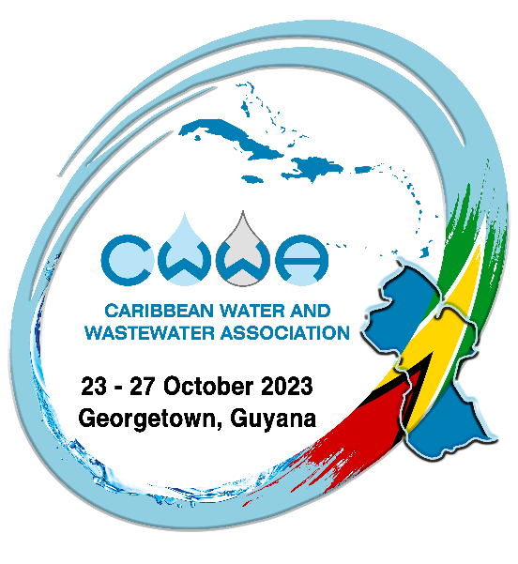
Caribbean Water and Wastewater Association

32nd Annual Conference and Exhibition
23 - 27 October 2023
Georgetown, Guyana

ABSTRACT SUBMISSION FORM

“Accelerating Change in the Water, Wastewater,
and Solid Waste Sectors

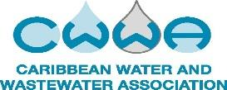
Please complete one form per presentation.
Deadline for submission of abstracts: 12th June 2023
Abstracts submitted by this deadline will have precedence.

Title of
Presentation
Name of Primary Presenter
Presenter Title
Organisation
Mailing Address
City | Region Three | Country |  | Guyana | State/Zip
Telephone |  | Fax
E-mail Address
Name(s) of Co-Presenter(s)
Presentation Subject Area (mark all that apply):
Policy, Governance, and Finance as the foundation for sustainable management
☐ Inclusive policy development for advancing the water and waste sectors
☐ Challenges and solutions for cross-sectoral cooperation
☐ Transboundary water management for sustainable development
☐ Good governance for the development of the water and waste sectors
☐ Disaster preparedness and risk management
☐ The Water-Food-Energy nexus
☐ Financing in the water and wastewater sectors
☐ Other: Click here to enter text.
Leaving just our footprint: Integrated Solid Waste Management
☐ Source to sea: getting ahead of the game
☐ Solid waste as a threat to inland water resources
☐ Circular economy in the solid waste sector
☐ Marine plastic litter in a changing world
☐ Financing the solid waste sector
☐ Reducing plastic waste with sustainable alternatives
☐ Solid waste management in the Caribbean
☐ Other: Click here to enter text.
Every drop counts in a climate resilient Caribbean
☐ Valuing water: the true cost of water
☐ Financing the reduction of NRW in the Caribbean
☐ Water-loss management in distribution systems: pressure monitoring, DMAs, and metering
☐ NRW assessment and strategy design
☐ Leak detection technologies and strategies
☐ Organisational and institutional challenges and strengthening
☐ Capacity building and cultural shift in fighting NRW
☐ Other: Click here to enter text.
Making water for all achievable through innovation and technology
☐ Water supply infrastructure
☐ Technologies for sustainable water management
☐ Innovative water treatment technologies
☐ Innovative wastewater treatment technologies
☐ Water, sanitation, and hygiene (WASH) in rural communities
☐ Wastewater as a community health indicator
☐ Emerging water borne threats
☐ Other: Click here to enter text.
Looking at the whole picture: Integrated Water Resources Management
☐ Valuing the ecosystem services of water
☐ Climate resilient water infrastructure
☐ Combating climate induced drought conditions
☐ Circular economy in the water and wastewater sectors
☐ Caribbean under sea: adapting to floods and sea level rise
☐ Nature-based solutions for water resources management
☐ Water Action for a climate resilient Caribbean
☐ Other: Click here to enter text.
Intended Audience (mark all that apply)
☐ Water Utility Managers/Planners  ☐ Wastewater Utility Managers/Planners  ☐ Solid Waste Managers/Planners  ☐ Water Operators/Technicians  ☐ Wastewater Operators/Technicians  ☐ Landfill Operators/Technicians |  |  | ☐ Regulators  ☐ Policy Makers  ☐ Academia  ☐ Environmental Groups  ☐Other: Click here to enter text.

PLEASE SEE NEXT PAGE FOR ENTERING PRESENTERS BIO AND PAPER ABSTRACT

COMPLETE AND E-MAIL (WORD/PDF) TO: cwwatechnical2023@gmail.com

SEND CONCERNS TO: cwwaconference2023@gmail.com OR conference@cwwa.net

Presenter Biography: (please provide one or two short paragraphs)

Presentation Abstract: (please keep length to no more than 300 words)

