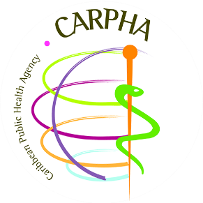

CALL FOR EXPRESSION OF INTEREST:
TO REVIEW AND STRENGTHEN POLICY, LEGISLATIVE AND INSTITUTIONAL CAPACITY TO SUPPORT SUSTAINABLE LAND AND WATER RESOURCES AND ECOSYSTEMS MANAGEMENT IN IWECO PARTICPATING STATES

CONSULTING FIRM
The Caribbean Public Health Agency (CARPHA), with funding from the United Nations Environment Programme (UNEP) - funded Programme of the Integrating Water, Land and Ecosystems Management in Caribbean Small Island Developing States (GEF-IWEco Project), is seeking to engage a contracting firm to review and strengthen policy, legislative and institutional capacity to support sustainable land and water resources and ecosystems management in IWEco participating states

BACKGROUND, OBJECTIVE, SCOPE OF WORK
See attached Terms of Reference for details.
INVITATION

CARPHA invites eligible consulting firms to indicate their interest in providing the services. Interested consulting firm must provide information indicating that they are qualified to perform the services ( description of similar assignments, experience in similar conditions, availability of appropriate skills among staff, business profile, CVs etc.). Suitably qualified consulting firms will be short-listed and invited to tender for the Project through a competitive procedure.

COSTING AND IMPLEMENTATION

The maximum value of the consultancy is $120,000 USD. The intended start date is April, 2020 and the period of implementation of the contract will be six (6) months from this date, including the Final Report.
DEADLINE FOR SUBMITTING EXPRESSIONS OF INTEREST

Expressions of interest must be delivered in English by email to the address below by Wednesday 29 January 2020 at 4:30pm Atlantic Standard Time (AST) to:

Caribbean Public Health Agency
Mr. Anthony Seunarine
Procurement Manager

Telephone: 1-868-622-4261/2
Fax: 1-868-622-2792
E-mail: seunaran@CARPHA.ORG

